A Project Report On

### WEB WALLAT

*Submitted in partial fulfillment of the requirements for the degree of*

***Diploma Engineering In***

***Computer Engineering***

***Submitted by***

**Panja Rayyan**

*(Enr. No.* ***206920307052****, 5th Sem)*

**Vachhani Tejas**

*(Enr. No.* ***206920307051****, 5th Sem)*

**Kotak Dixit**

*(Enr. No.* ***206920307001****, 5th Sem)*

***Under the guidance of***

**Internal Guide Prof. Vrunda Joshi**

***Submitted to***



Noble Group of Institutions-Junagadh

**Gujarat Technological University, Ahmadabad**

Year 2022-2023

**NOBLE GROUP OF INSTITUTIONS JUNAGADH**

***CERTIFICATE***

This is to Certify that Mr.  **Panja Rayyan** Enrollment No.

206920307052 of Diploma Semester **V** of **Department Computer** has satisfactorily completed his project work for partial fulfillment for the



duration of **July 21** to **November 12 , 2022**

To the best of my knowledge and belief, this work embodies the work of candidate herself, has duly been completed, fulfills the requirement of the ordinance relating to the Diploma Engineering of the

university and is up to the standard in respect of content, presentation and

language for being referred to the examiner.

**Guided By Head of Department**

**Prof. Vrunda Joshi Prof. Rajesh Samata**

**NOBLE GROUP OF INSTITUTIONS JUNAGADH**

***CERTIFICATE***

This is to Certify that Mr.  **Vachhani Tejas** Enrollment No.

206920307051 of Diploma Semester **V** of **Department Computer** has satisfactorily completed his project work for partial fulfillment for the



duration of **July 21** to **November 12 , 2022**

To the best of my knowledge and belief, this work embodies the work of candidate herself, has duly been completed, fulfills the requirement of the ordinance relating to the Diploma Engineering of the

university and is up to the standard in respect of content, presentation and

language for being referred to the examiner.

**Guided By Head of Department**

**Prof. Vrunda Joshi Prof. Rajesh Samata**

**NOBLE GROUP OF INSTITUTIONS JUNAGADH**

***CERTIFICATE***

This is to Certify that Mr.  **Kotak Dixit**Enrollment No.

206920307001 of Diploma Semester **V** of **Department Computer** has satisfactorily completed his project work for partial fulfillment for the



duration of **July 21** to **November 12, 2022**

To the best of my knowledge and belief, this work embodies the work of candidate herself, has duly been completed, fulfills the requirement of the ordinance relating to the Diploma Engineering of the

university and is up to the standard in respect of content, presentation and

language for being referred to the examiner.

**Guided By Head of Department**

**Prof. Vrunda Joshi Prof. Rajesh Samata**

ACKNOWLEDGEMENT

We would like to take this opportunity to express my gratitude towards all the people who have in various ways, helped in the successful completion of our project.

I wish to express my gratitude to **Vrunda Joshi**, Project Co-ordinator who have extended their kind help, guidance and suggestion without which it could not have been possible for me to complete this project report.

My sincere thanks to my all entire faculty members and all staff members for offering me all kinds of support and help in preparing the project.

I am deeply indebted to my guide **Vrunda Joshi** for not only her valuable and enlightened, guidance but also for the freedom she rendered me during this project work.

I am thankful to my classmates, well-wishers who with their magnanimous and generous help and support made it a relative easier affair.

My heart goes out to my parents who bear with me all the trouble I caused then with smile during the entire study period and beyond.

Panja Rayyan, (206920307052),

Vachhani Tejas, (206920307051),

Kotak Dixit, (206920307001),

C.S.E. Department,

Noble Group of Institution Junagadh.

**ABSTRACT**

This report describes our implementation of **Net** **Banking** information. We used the Entity-Relationship model to design a database that will store the data of Our Users/Account Holders(Those Who have Created Bank Account using our teams Project). We have created the database using MYSQL(MARIA DB) and populated it with some sample data. The system can keep list of Main Account Details of Users/Account Holders, We Have a Loan Section which Stores Data of Loan Requests If a user has applied or Taken loan, & A contact table which contains Question and Messages Sent by our Users/Account Holders. We have created an Internet-based Banking System application.

|  |  |  |
| --- | --- | --- |
|  | **CONTENT** |  |
| **SR NO.** | **TOPIC** | **PAGE NO.** |
|  | **Certificate** | **I** |
|  | **Acknowledgement** | **Ii** |
|  | **Abstract** | **Iii** |
|  | **List of Content** | **iv** |
|  | **List of Figures** | **vi** |
|  | **List of Tables** | **Vii** |
| **Chapter-1.** | **Introduction** | **1** |
|  | 1.1 Purpose | 2 |
|  | 1.2 Scope | 2 |
|  | 1.3 Technology and Literature Review | 3 |
|  | 1.4 Why Web-Tech is used? | 3 |
| **Chapter-2.** | **Project Management** | **4** |
|  | 2.1 Project Planning and Scheduling | 5 |
|  | 2.2 Risk Management | 6 |
|  | 2.3 Estimation | 7 |
|  | 2.4 Cost of Analysis | 8 |
| **Chapter-3.** | **System Requirement Study** | **10** |
|  | 3.1 User Characteristics | 11 |
| **Chapter-4.** | **System Analysis** | **13** |
|  | 4.1 Problem Definition | 14 |
|  | 4.2 Fact Find Techniques | 14 |
|  | 4.3 Need for Computerization | 16 |
|  | 4.4 Process Model | 16 |
|  | 4.5 Requirement Analysis | 18 |
|  | 4. 6 Feasibility Study | 18 |
|  | 4. 7 Requirement Validation | 19 |
| **Chapter-5.** | **System Design** | **21** |
|  | 5.1 Data Flow Diagram | 22 |

|  |  |  |
| --- | --- | --- |
|  | 5.2 E-R Diagram | 24 |
|  | 5.3 Use case Diagram | 25 |
|  | 5.4 Activity Diagram | 26 |
| **Chapter-6.** | **Data Dictionary** | **28** |
|  | 6.1 Database Dictionary | 29 |
| **Chapter-7.** | **Implementation Planning** | **35** |
|  | 7.1 Fundamental of Software Implementations | 36 |
|  | 7.2 Security Features | 37 |
|  | 7.3 Coding standard | 37 |
| **Chapter-8.** | **Input And Output Design** | **38** |
|  | 8.1 Screen Layout | 39 |
| **Chapter-9.** | **Limitation And Future Enhancements** | **44** |
|  | 9.1 Limitation | 45 |
|  | 9.2 Advantages | 45 |
|  | 9.3 Future Enhancements | 46 |
| **Chapter-10.** | **Conclusion** | **46** |
| • | **References** | **49** |

### LIST OF FIGURES

|  |  |  |
| --- | --- | --- |
| **FIGURE NO.** | **NAME OF FIGURE** | **PAGE NO.** |
| 4.1 | Incremental Software Model | 17 |
| 5.1 | Data Flow Diagram Level 0 | 23 |
| 5.2 | Data Flow Diagram Level-1: | 23 |
| 5.3 | E-R Diagram | 24 |
| 5.4 | Use case diagram: Admin | 25 |
| 5.5 | Activity Diagram: Admin | 27 |
| 6.1 | Details about Admin Table | 2 9 |
| 6.2 | Details about Admin Table | 29 |
| 6.3 | Details about Category Table | 30 |
| 6.4 | Details about Subcategory | 30 |
| 6.5 | Master Production Table | 31 |
| 6.6 | Medical Information Table | 32 |
| 6.7 | Doctor Show Table | 32 |
| 6.8 | User Show Table | 33 |
| 6.9 | Blog Table | 33 |
| 6.10 | Feedback Table | 34 |
| 8.1 | Login Table | 39 |
| 8.2 | Category Table | 40 |
| 8.3 | Sub Category Table | 40 |
| 8.4 | Master Category Table | 41 |
| 8.5 | Medical Information Table | 41 |
| 8.6 | Doctor Info Table | 42 |
| 8.7 | User Show Table | 42 |
| 8.8 | Blog Table | 43 |
| 8.9 | Feedback Table | 43 |

**LIST OF TABLES**

|  |  |  |
| --- | --- | --- |
| **TABLE NO.** | **NAME OF TABLE** | **PAGE NO.** |
| 5.1 | Symbol and Abbreviation | 22 |
| 5.2 | Activity Diagram Symbols | 26 |

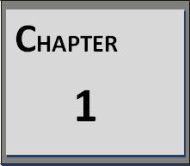

**INTRODUCTION TO PROJECT**

* 1. **Purpose**
  2. **Scope**
  3. **Technology and Literature Review**
  4. **Why Android Is Used?**

# Chapter 1 Introduction to Project

#### PURPOSE

The main goal of this project is to provide a easy and good banking Experience to the end user so that our user don’t have to be worried about his money management.

In present time, Web technology are very famous, so the main objective behind this project is we can get knowledge of Web application and get aware of Web technology.

#### SCOPE

This project will be an Web-Application by which a person can get all information about his Bank Account and if the end user desires so that he can transfer money to another Bank Account(of Another User) We Provide Loan Application System as well in our Web Application Through which if a user is in dire need of money he can get access to this money for a period of time. Our Web Server and the database will be maintained by the admin so that data security can be maintained.

##### In Scope

The system will be used by each and everyone interested in get a good interface of Banking System For themselves and Provide Easy Money Transfer Security with Accuracy . Our Main objective is to provide successful result that meet all needs of Account Holder and enhance the features of existing System by overcoming the problems faced in past(Currently We Are on Version 3.0.0 as Upgrade our Project 3 times to get/provide better output). As the application requires the license for deployment on internet, this becomes the limitation for our application

#### TECHNOLOGY AND LITERATURE REVIEW

**Front-End** Html(HTML5), CSS(CSS3), JavaScript(ES6)

**Back-End** PHP(Version 7.4),MySQL(Version 5.6)

#### WHY WEB IS USED?

Web Services Are Widely Used Technology Web Services are Preferred over Android Services. Mostly Every Big Companies Like Google, FaceBook(Meta), Netflix Holds Web Services First. In our project we have used Web languages Such as HTML, CSS, JavaScript , PHP, MySQL To Create a Dynamic Web Application . It is easy to build dynamic and interactive Web Applications Using Following Languages

#### WHY MYSQL DATABASE IS USED?

##### What Is MYSQL?

##### MySQL Database is a client/server system that consists of a multithreaded SQL server that supports different back ends, several different client programs and libraries, administrative tools, and a wide range of application-programming interfaces (APIs). MYSQL also provide MySQL as an embedded multithreaded library that you can link into your application to get a smaller, faster, easier-to-manage standalone product.

##### MYSQL is Widely Used Database.

Many of the world's largest and fastest-growing organizations including Facebook, Twitter, Booking.com, and Verizon rely on MySQL to save time and money powering their high-volume Web sites, business-critical systems and packaged software.

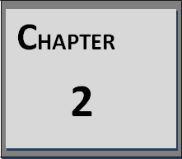

**P**ROJECT **M**ANAGEMENT

* 1. **Project Planning and Scheduling**
  2. **Risk Management**
  3. **Estimation**
  4. **Cost Analysis**

# Chapter 2

# Project Management

E:\Capture33.PNG

#### PROJECT PLANING AND SCHDULING

Planning before any activity is very much important. And if it is planned nicely, then success is guaranteed. Project Management System has six major modules of Admin, Manage Application, Test Management, Process Management, Manage Comment, Reports. We analyzed the overall complexity of each of these modules and it was found that the project will required approximately 16 weeks completing, so we planned accordingly. We decided to follow the SDLC i.e. Software Development Life Cycle while planning various phases of our project. This method consists of following activities:

1. Determination of system requirements
2. System Analysis
3. Design of system
4. Development of software
5. System Testing
6. Implementation and Evaluation
7. Debugging or running

We have planned our project into following ways:

* During first month of our project, we have understood the main objectives behind this project, collected the requirements, analyzed the requirements, checked the feasibility of the project and started designing the database.
* During second month of our project, we have started to make database of our project development.
* During third month of our semester, we started designing our project.
* On Last Second month of Our Semester We Completely Finished Designing and We Keeps on adding new Stuffs in our website.

##### WHY PROJECT MANAGEMENT IS NECESSARY?

Project management involves the planning, monitoring, and control of the people, process, and the events that occurs as involves from a beginning concept to an operational implementation. Software project management is an umbrella activity within software engineering. Four P’s have a substantial influence of software project management – People, Process, Project, and Product. People must be organized into effective teams, motivated to do high-quality software work, and coordinated to achieve effective communication. The Process framework is selected, and appropriate software engineering concept is applied, and set of work tasks is chosen to get the job done.

The Project must be organized in a manner that enables the software team to succeed. The Product requirement must be communicated from customer to develop, portioned into their constituted parts, and positioned for work by the software team. A project Management activity encompasses measurement and metrics, planning, schedules, risk analysis, estimation, tracking, and control.

##### OBJECTIVES

To provides a framework that enables the manager to make seasonable estimate of resources cost and schedule. The estimate are made within a limited time frame at the beginning of the software project be updated regularly as project progresses.

#### RISK MANAGEMENT:

##### "Risk is the potential future harm that may arise from some present action"

Risk Management is a process that is used to minimize or eliminate risk before it can harm the productivity of a software project. With only 28% of software projects finishing on time and on budget, risk and the management of risk play an important role in software development. There are two ways that software engineers can handle risk. A reactive software engineer corrects a problem as it occurs, while a proactive software engineer starts thinking about possible risks in a project before they occur.

Here are several types of risk that can occur during a software development project.

These include:

There are also specific risks associated with team members, customers, tools, technology, time estimation, and team size. Many of these risks can be minimized by the development methodology used for the project. There are many different tools that can be used to analyze the risk apparent in a project and that can help choose the best way to minimize or eliminate that risk.

##### RISK IDENTIFICATION:

Time estimation risk and technology risk are challengeable for our application. Total Pets Solution will developed many ways like using windows workflow foundation, Xml, Database etc so how we can identify which will be more preferable for our application and which will give best result compare to all technology and also give best outcomes. If we select any one technology for our application and go through it that time any challenge will come so how we can switch over new technologies and learn about new technology thus it will very time consuming.

##### RISK ANALYSIS AND PLANNING

To handle the risks I have prioritized it. The damaging risks can be handled first and then most likely risks. Since the risk related to the schedule failure arise primarily due to the intangible nature of the software, so I had to do the visibility of software requirements documentation and reviewing the relevant documents during the developments. Every phase can be broken into the reasonably sized tasks and milestones can be scheduled for these tasks.

In this process each identified risk is considered in turn and a judgment made about the probability and the seriousness of the risk.

1. The probability of the risk might be assessed as very low (less than 10%), low(10- 25%), moderate (25-50%), high (50-75%) or very high (greater than 75%).
2. The effects of the risk might be assessed as catastrophic, serious, tolerable or insignificant.

#### ESTIMATION

##### Effort Estimation

Each company determines the output it expects from its team members. Let us call the average output of a team member per man-hour as the unit output. Assume that

one has to deliver an end-to-end login module's functionality for an application. The time spent on the login functionality should include the corresponding time required for gathering the requirements, doing a requirement analysis, architecture inputs, form design, object/class design, implementing the business rules, data validation and storage, framework (i.e., code for login module's constants, enumerations, utilities), testing, debugging, deployment up to user acceptance, etc.

Now, the estimator has to figure out how many man-hours it would take to complete the login module, keeping all these factors in mind. The sequence of work and dependencies should be considered as they do cause delays in completion. For example, form design should be done first (all the way up to acceptance by the customer), then object design (up to acceptance by the architect), followed by coding (for business rules, calculations, and data validations), internal testing, and user acceptance testing. A wise estimator would always take support from other people to understand the scope of work to do a given task.

#### COST ANALYSIS

Organization is one module of my applications, so it could justify it if the total effort to complete all these activities is 3 man hours. Now, if it costs the company rupees 600/- per hour (for a programmer, and workstation including hardware and software), then the basic cost of developing the Organization module is

##### 3 (man hours) x 600 (Rupees) = 1800.00 (Rupees).

Estimators should also try to map older projects to new ones. This would give them an idea of the broader picture of the time spent, and they could then try to distribute the man hours across the application's modules and phases.

##### CONVERT COMPLEX STUFF TO SIMPLE STUFF

The number of hours required to develop a simple registration feature (end-to- end) would be within the abilities of most estimators. The registration form would include User Type, Organization name, Application name, Username, Password. In my

opinion, this is approximately the same as the login page, so let us put 10 hours again. A still more complex form having around 10 GUI elements with several business rules and data validation would probably take a lot more time. In such a case, try to separate out sets of GUI elements and functionality so that each part appears to be similar in scope to the simple registration form.

Then, add up the number of simple registration forms that you have derived out of the complex form, multiply it by the number of man-hours per simple registration form, and first, you've got the number of man-hours to develop the complex registration form.

##### (man hours) x 600 (Rupees) = 1800.00 (Rupees).

The same concept can be applied to business objects whose functionality is complex. The objects should be simplified into simple objects for which effort can be more easily determined. When developing a common event-handling component for the application, try to first break it down into easier to understand 'pieces'. Assuming that event handling component would involve logging certain type of events and excludes event fired on the presentation tier and database tier.

Logging should be a separate component to be developed as it may also involve exception logging, security logging, performance logging, disk usage logging, C.P.U. logging etc. So, take out the logging component development when estimating the event object (it only uses the logging component). Now, the event object would involve defining events to be handled, data if any to be passed by the event, and developing event handlers for those events. Slowly, you will find that it is easier to figure out the effort involved to develop this component.

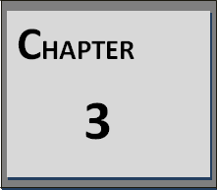

**SYSTEM REQUIREMENT STUDY**

* 1. **User Characteristics**

# 

# Chapter 3

E:\Capture33.PNG**System Requirement Study**

#### USER CHARACTERISTICS:

The User characteristic defines the different types of users involved in the system. Users are the actors that deal with the system and they play the major role in the system.

The Banking Networks has the Two types of users that play the different activities In the system.

##### Administrator:

* + Login
  + Loan Approval / Rejection
  + Depositing Amount
  + Remove An Account
  + Deduct Loan Amount
  + Upload Loan Packages
  + Review Feedbacks

##### User:

* + Login / Registration
  + Transfer Money
  + Application of Loan
  + Check Balance
  + Contact Admins
  + Settings to Change : Name, Password, Address, Email, Contact Number
  + Checking Progress of Loan Applcation or Feedback**s**

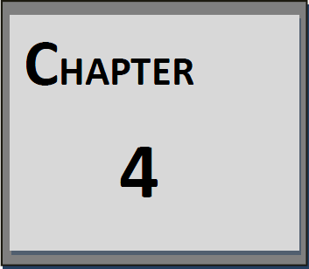

**SYSTEM ANALYSIS**

* 1. **Problem Definition**
  2. **Fact Finding Techniques**
  3. **Need for Computerization**
  4. **Process Model**
  5. **Requirement Analysis**
  6. **Feasibility Study**
  7. **Requirement Validation**

# C:\Users\hiral\Desktop\capture\cc.PNGChapter 4 System Analysis

#### PROBLEM DEFINITION

Here we have defined a products related to general which will guide the customer to choose the right product for customer .This will be an app-enable service that can be accessed from anywhere in the world through the internet.

##### Definition:

**What is DA?**

DA is a system which will provide information about various general medicine

.DA will provide information about various products to customer. DA will also provide information of every disease and its medicine.

All the information will be provided centrally via the internet. Users will be able to register in to DA and users will be able to securely log-in to the DA. It is compulsory to login or register in DA login or registration is compulsory.

#### FACT FINDING TECHNIQUES

Fact-finding is an important activity in system investigation. In this stage, the functioning of the system is to be understood by the system analyst to design the proposed system. Various methods are used for this and these are known as fact-finding techniques. To study any system the analyst needs to do collect facts and all relevant information. The facts when expressed in quantitative form are termed as data. The success of any project is depended upon the accuracy of available data. Accurate information can be collected with help of certain methods/ techniques. These specific methods for finding

information of the system are termed as fact finding techniques.

We use document **s**ampling, questionnaires, **i**nterviews, background **r**eading and

**o**bservation (SQIRO) this is the technique to discover facts about an existing system.

##### SQIRO

* + **Reading**

We aim to understand the business. We look at reports, manuals, job descriptions, catalogues, Internet, stocks and shares etc.

##### Advantages

Help us to understand the business before we interview employees and start designing new systems.

##### Disadvantages

Written documents may be out of date or not reflect what actually happens.

##### INTERVIEWING

We try to understand what actually happens from the managers, the users and the customer’s point of view.

##### Advantages

* + - Personal contact can allow us deeper insight into what actually happens

##### Disadvantages

* + - It can be time consuming and costly.
    - The people being interviewed may feel uncomfortable and un-cooperative.
    - Interview notes need writing up immediately after the event.
    - Requires skill and expertise.

##### OBSERVATION

We see with our own eyes what actually happens.

##### Advantages

* + We get first-hand experience of how the system works.
  + We can compare what we see with what we have been told.

##### Disadvantages

* + People do not like being watched and may change their behavior from what they normally do.
  + We may not be allowed to see personal data

##### SAMPLING

We look at forms, reports, screens, records.

##### Advantages

* + - We can see what data is involved, and how much.

##### QUESTIONNAIRES

We reach people we could not interview.

##### Advantages

* + - We can get information from a large number of people for the least possible cost.
    - Results can be read by machine and therefore easy to analyze.

#### NEED FOR COMPUTERIZATION

There are many options available nowadays for bakery products. People have to run around to different places, shop, mall, etc. for guidance on chose good products. Each shop may have different price. This information may not be readily available. Dhyanshi Bakery Shop is an open field Marketing It does not require any office to be setup. Its growth depends on members how they Work hard.

So if centralized computer system is there then some problems can be overcome. Customers will get all the information on a single click and they do not have to rush at different places.

#### PROCESS MODEL

To solve actual problem in industry setting, software engineer or a team of engineers must incorporate a development strategy that encompasses the process, methods and tools layers and generic phases. This strategy is often referred to as process model or a software engineering paradigm. A process model for software engineering is chosen based on the nature of the project and application, the methods and tools to be used, and the control and deliverables that are required.

##### Incremental Software Model:

We are using the Incremental software model for this project. The Incremental model delivers software into small pieces called “increments”. In general, each increment builds on those that have already been delivered. That is why, we are implementing

incremental model. In addition, it combines elements of waterfall model with the iterative philosophy of prototyping.

##### *First Step: - Communication & Analysis

In communication phase the major task performed is requirement gathering which helps in finding out exact need of customer. Once all the needs of the customer are gathered the next step is planning.

##### *Second Step: - Planning

In planning major activities like planning for schedule, keeping tracks on the processes and the estimation related to the project are done. Planning is even used to find the types of risks involved throughout the projects. Planning describes how technical tasks are going to take place and what resources are needed and how to use them

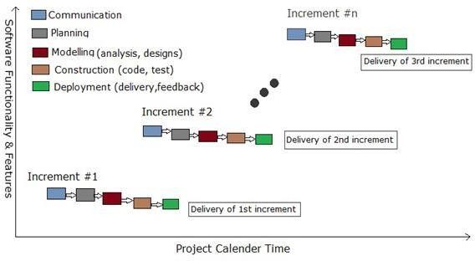

##### *Third Step:- Modeling

***Fig. 4.1:- Incremental Software Model***

This is one the important phases as the architecture of the system is designed in this phase. Analysis is carried out and depending on the analysis a software model is designed. Different models for developing software are created depending on the requirements gathered in the first phase and the planning done in the second phase.

#### REQUIREMENT ANALYSIS

Requirement and specification are very important components in the development of any project. Requirement analysis is the first step in the system design process, where a user’s requirements should be clarified and documented to generate the corresponding specifications. While it is a common tendency for designers to be anxious about starting the design and implementation, discussing requirements with the customer is vital in the construction of safety-critical systems. For activities in the first stage has significant impact on the downstream results in the system life cycle. For example, errors developed during the requirements and specifications stage may lead to errors in the design stage. This leads not only to more time wasted but also the Possibility of other requirement add specification Therefore, it is necessary that the requirements are specified correctly to generate clear and accurate specifications.

The first step toward developing accurate and complete specifications is to establish correct requirements. In requirements, it is important to specifically establish the function, attributes, constraints, preferences, and expectations of the project. Usually in the process of gaining information, functions are the first ones to be defined. Functions describe what the project is going to accomplish. It is also important to determine the attributes of a project. Attributes are characteristics desired by the client, and while 2 projects can have similar functions, they can have completely different attributes. After all the attributes have been clarified and attached to functions, we must determine the constraints on each of the attributes. Preferences, while is a desirable but optional condition placed on an attributes, can also be defined in addition to its constraints. Finally, we must determine what the client’s expectations are. This will largely determinethe success of the project.

#### FEASIBILITY STUDY

The feasibility is the measure of how beneficial or practical the development of information system will be to an organization.

* Feasibility of projects can be changed during the system development.
* To revolute feasibility there is different checkpoint in the development. A project may be canceled or revised at any checkpoint despite whatever resources have been spent.
* Costs must eventfully be recovered if the investment is ever to be considered a success.
* There are five different type of feasibility, which we discuss below.

##### Operational Feasibility

The factors concerted:

* + Our project work on online business is an absolutes necessity for a growing particular business site like sane as India mart or online business and etc...
  + This project life online business system can be easily run on the internet.
  + Operational feasibility was always out question. This company is needs fast as possible and it had to be cost effective. It is often performed with a working prototype of the proposed system.
  + Our system customer user can be easier to use our life insurance system and show to the information form and rose.
  + Also our user can be online fill the form directly and also show the information, show rules etc...
  + It also can impact on the schedule. After a series of discussions we ended with WPF technology and started to our Internet Information Server.
  + These are new technology that are including in the business rules and work it. This is really a growing technology and having more functionality for the development of the web application.
  + Any types of file format can be read. The database to be used was SQL server.
  + This database is very similar with the professionals and also having the Reasonable amount of benefits.

#### REQUIREMENT VALIDATION

Requirement validation is concerned with showing that the requirement actually defines the system which customer wants. It has much common with analysis as it is concerned with finding problems with the requirement. However they are distinct

processes since validation should be concerned with a complete draft of the requirement document whereas analysis involves working it incomplete Requirement.

During requirement validation process different types of check should be carried out on the requirement in the requirement document.

This check includes:

##### Validity Check:

A user may think that system is needed to perform certain function. However further thought and analysis may identify additional or different functions that are required. System diverse users with different needs and set of requirement are inevitably a compromise across the user community.

##### Consistency Check:

Requirement in the document should not conflict. That is there should not be contradictory constraints or different description of the system function.

##### Completeness Check:

The requirement document should include requirement, which define all function, and constraints intended by the system user.

##### Realism Check:

Using knowledge of used technology the requirement should be checked to ensure that they can actually be implemented. To reduce the potential for dispute between customer and developer, system requirement should always be written so that they are verifiable. This means that a set of checks can be designed which can demonstrate that the delivered system meets that requirement, which will also help user at the time of testing. The basic and initial criteria in our project are of username and password for any customers and administrator. Each new customer has to register all the details required for his entry in the database. Following are some of the validations that we have put at various places in our system.

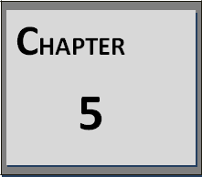

**SYSTEMD DESIGN**

* 1. **Data Flow Diagram**
  2. **E-R Diagram**
  3. **Use Case Diagram**
  4. **Activity Diagram**

# C:\Users\hiral\Desktop\capture\cc.PNGChapter 5 System Design

#### DATA FLOW DIAGRAM

Data Flow Diagrams show the flow of data from external entities into the system, and from one process to another within the system. There are four symbols for drawing a DFD:

##### *Rectangles

Rectangles representing *external entities*, which are sources or destinations of data.

##### *Ellipses

Ellipses representing *processes*, which take data as input, validate and process it and output it.

##### *Arrows

Arrows representing the *data flows*, which can either, be electronic data or physical items.

##### *Open-ended rectangles or a Disk symbol

Open-ended rectangles or Disk symbol representing *data stores*, including electronic stores such as databases or XML files and physical stores such as filing cabinets or stacks of paper. The Detailed DFD provides a more detailed and comprehensive view of the interaction among the sub-processes within the system.

The Detailed DFD provides a more detailed and comprehensive view of the interaction among the sub-processes within the system.

The Symbols that are used in the data flow diagram carry the following meaning

***Table 5.1:- Symbol and Abbreviation***

|  |  |  |
| --- | --- | --- |
|  | **Rectangle** | It Symbolizes The Source |
|  | **Ellipse/Circle** | It Symbolized A Process |
|  | **Marked Line** | It Symbolizes Connectivity With Dataflow. |
|  | **Data store** | It Is For Data Store |

***DATA FLOW DIAGRAM LEVEL 0:**

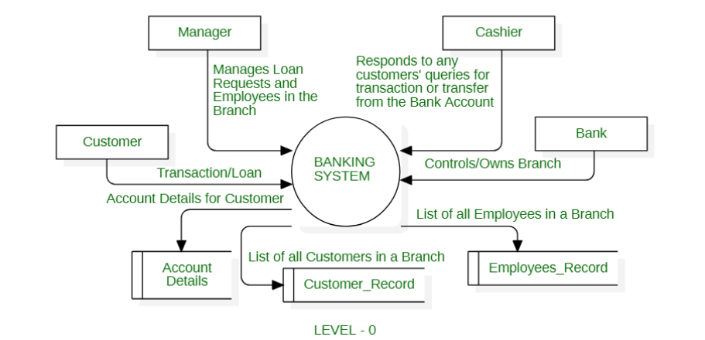

***Fig 5.1:- Data Flow Diagram Level 0***

##### DFD Level-1:

***Fig 5.2:- Data DFD Level-1***

* 1. **E-R DIAGRAM**

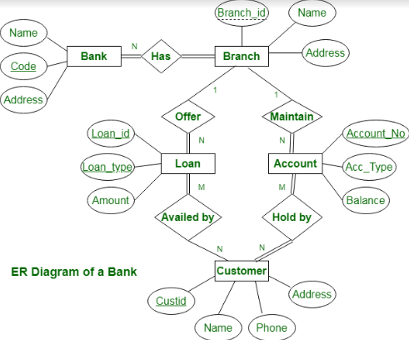

***Fig 5.3:- E-R Diagram***

#### USE CASE DIAGRAM

##### *Use Case Diagram For Admin

##### 

***Fig 5.4:- Use case diagram Admin***

#### ACTIVITY DIAGRAM

The Diagram is a simple way to represent the workflow and their steps of an entire system or a subsystem. In the unified Modeling Language an **activity diagram** represent the business and operational step-by-step workflow of components in a system. It shows the overall flow of control. It is a dynamic diagram that shows the activity and the event. **Symbols Used in Activity Diagram are shown in below table.**

***Table: 5.2: Activity Diagram Symbols***

|  |  |  |
| --- | --- | --- |
| **Symbol** | **Name** | **Description** |
|  | **Activity** | Represented by a rectangle with rounded edges |
|  | **Decisions** | Similar to flowcharts, a logic where a decision is to be made is depicted by a diamond, with the options written on either side of the arrows emerging from the diamond, within box brackets. |
|  | **Concurrent Activity** | Some activities occur simultaneously or in parallel. Such activities are called concurrent activities. This is represented by a horizontal split and the two concurrent activities next to each other, and the horizontal line again to show the end of the parallel activity. |

##### *Activity Diagram of Admin:-

##### *Fig 5.5:- Activity Diagram of Admin*

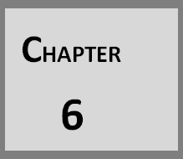

**DATA DICTIONARY**

**6.1 Data Dictionary**

E:\Capture33.PNG**Chapter 6 Data Dictionary**

#### 6.1 DATA DICTIONARY (Database Structure)

* **Wallet Database**

***Fig 6.1:- Wallet Database***

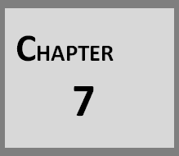

**IMPLEMENTATION PLANNING**

* 1. **FUNDAMENTAL OF SOFTWARE IMPLEMENTATION**
  2. **SECURITY FEATURES**
  3. **CODING STANDARDS**

## E:\Capture33.PNGChapter 7 Implementations Planning

#### FUNDAMENTAL OF SOFTWARE-IMPLEMENTATIONS

They are relatively easy to learn and use: .The user uses multiple screens for system interaction. Switching from one task to another is possible without losing sight of information generated during the first tasks. Fast full screen interaction is possible with immediate access to anywhere on the screen. Good user interface design is critical to the success of a system. An interface that is difficult to use it at best result in high level of user errors. At worst users will simply refuse to use the website irrespective of its functionality. If information is presented in confusing or misleading way user may misunderstand the meaning of information.

The system which we have developed is the client server application with Multi User facility and it is GUI based. Here four possibilities are there.

* + 1. Single user and GUI
    2. Single user and Non GUI
    3. Multi user and GUI
    4. Multi user and Non GUI

##### Single user and GUI:

Single user means at a time one user use the system and satisfied with the GUI of the system means designing part has been implemented as per the client satisfaction.

##### Single user and Non GUI:

Here in this possibility, single user means at a time one user use the system and Non GUI means features as well as all functionalities of the system have been implemented as per the client satisfaction.

##### Multi user and GUI:

Multi user means at a time more than one user use the system from any place(through online) by their own USB lock, User name and password which have

been given from the company and satisfied with the GUI of the system means designing part has been implemented as per the clients satisfaction.

##### Multi user and Non GUI:

Multi user means at a time more than one user use the system from any place(through online) by their own USB lock, User name and password which have been given from the company and Non GUI means features as well as all functionalities of the system have been implemented as per the client satisfaction.

#### SECURITY FEATURES

##### Form Based Authentication:

Only Admin is authenticated to create new user, select user type, Add organization details and Application details.

##### Initially Must be Login:

Only Authenticated users are allow to add and update rules.

##### Path of the Assembly is encrypted

Other Users of the system except Admin cannot know where the .dll files reside. All the users of the system Compulsory have to pass from the login form. For login with user name and password. If Username/Password will not match the person could not enter into the system.

Every User has assigned the rights or role for access the system. So another department person could not access the different department. The Duplicate Entries are prohibited on this application so the Conflict username could not be possible I this application. The database of this system is also password protected from the admin side on the

Company’s server so no one can modify the database.

#### CODING STANDARD:

Majority of the programmers write 'working code', but not „good code'. Writing 'good code' is an art and you must learn and practice it. Everyone may have different definitions for the term „good code‟. The following are the characteristics of good code.

**Reliable Maintainable

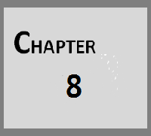

**INPUT AND OUTPUT DESIGN**

**8.1 SCREEN LAYOUT**

## Chapter 8

E:\Capture33.PNG**Input And Output Method**

#### 8.1 SCREEN LAYOUT

#### 

##### Landing Page

##### *Fig 8.1:- Landing Page*

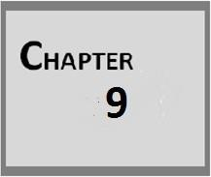

**LIMITATION AND FUTURE ENHANCEMENCTS**

* 1. **LIMITATIONS**
  2. **FUTURE ENHANCEMENTS**

## Chapter 9

E:\Capture33.PNG**Limitation And Future Enhancements**

#### LIMITATION

Though we tried our best but due to some reasons like time available the system has some limitations as compared to the other content providers. Since these limitations can be easily removed. Here we will discuss these things

* All the page and database are stored at server side so if server goes down then system cannot respond.
* Customer can change only their personal information themselves.
* There is no downloading or uploading.
* The system requires browser to run.
* Web Application requires internet connection for entire operation. There is no offline mode

#### ADVANTAGES

* DA will provide Fast Money Transactions.
* DA will provide Safe and Secure Transactions.
* All the information Of the is Going to Private Only Accessible By Authorized User Only.
* Users will be able to securely login to the DA system.
* DA will have standard security features which will prevent unauthorized access to the portal.
* Users will not have to install any additional software’s to access DA.
* DA will be user-friendly, understandable and easy to use.

#### FUTURE ENHANCEMENT

Each and every system contains scope for better developments. It means that each and every system has enhancement possibilities. In our project enhancement can be made like:

* Optimization to output the results rapidly.
* At last, In Future we will try to provide better & better design to our application.
* And, we try to provide better and better service to customers.

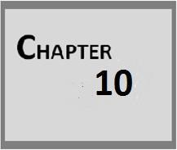

**CONCLUSION**

**10.1 CONCLUSION**

## E:\Capture33.PNGChapter 10 Conclusion

#### 10.1 CONCLUSION

Persons don't have complete knowledge regarding all products. They need accurate information available to them instantly in order to choice best products. The user should be aware of all the products options if they make a particular choice of good marketing.

Thus DA is a app-enable service that can be accessed from anywhere in the world through the internet. DA will provide all the information related to the good products. It will guide persons to choice better by selecting the right one.

## E:\Capture33.PNGREFERENCE

1. [http://www.w3school.com](http://www.w3school.com/)
2. [http://www.codepen.com](http://www.codeproject.com/)
3. https://www.geeksforgeeks.org/
4. <https://www.youtube.com/c/CodeWithHarry>
5. <https://www.youtube.com/kepowob>
6. <https://dribbble.com/>

**\*\*\*\*\*\*\*\*\*\*\*\*\*\*\*\*\*\*\***